Jail for Bridgeport cops in Beardsley Park stomping case
By Michael P. Mayko on February 5, 2015 4:01 PM

- 4
- 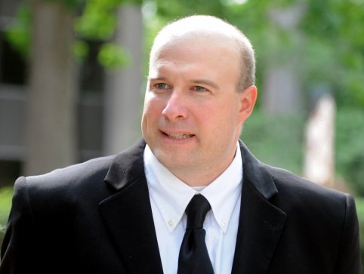
- 
- 
- 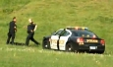
- 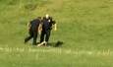
- 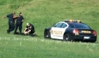
- 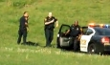
Autumn Driscoll
IMAGE 1 OF 6 | BEARDSLEY PARK STOMPING CASE
Joseph Lawlor leaves the U.S. District Court in Bridgeport, Conn., Tuesday, June 10, 2014, where he pleaded guilty to stomping a Tasered man in Beardsley Park. Lawlor, a 12-year veteran of the Bridgeport Police Department, faces up to a year in prison for the misdemeanor charge of violating a person's civil rights.
BRIDGEPORT — Two 12-year veteran police officers will both be spending three months in federal prison stemming from a May 20, 2011 stomping of a downed suspect in Beardsley Park.
U.S. District Judge Jeffrey Meyer told former Officers Elson Morales and Joseph Lawlor that with “great power comes great responsibility” in imposing the term.
“The law enforcement community is well attuned to what is going on in this case and in this courtroom,” Meyer said. “Every police officer must know the consequences of crossing the constitutional line…is not just loss of employment but loss of liberty.”
Morales is expected to begin serving his sentence on April 10 and Lawlor on March 9. Upon their release they will be under the supervision of a U.S. Probation officer for six months. Both have retired from the Bridgeport Police department as a result of their guilty plea to a federal misdemeanor charge of deprivation of constitutional rights.
The judge said their actions captured on a video that has gotten nearly 400,000 views impacted the public’s “fragile vulnerable relationship” with police.
He also noted that the city’s settlement of a federal civil case brought by the victim, Orlando Lopez Soto, cost Bridgeport taxpayers $198,000.
The 57-second video shows Lopez Soto being kicking and stomped on while on the ground.
A third officer, Clive Higgins, who arrived at the end of the video, was acquitted of any wrongdoing by a federal jury last month.

http://blog.ctnews.com/connecticutpostings/2015/02/05/jail-for-cops-in-beardsley-park-stomp/

Bridgeport police officer found not guilty of using excessive force during arrest
POSTED 5:51 PM, JANUARY 14, 2015, BY SAMANTHA SCHOENFELD

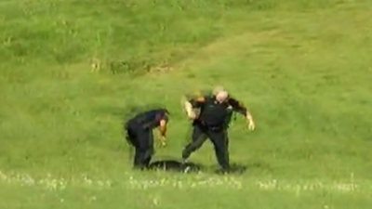
BRIDGEPORT–A police officer was found not guilty in Bridgeport on Wednesday after a trial accusing him of using excessive force during an arrest, according to the clerk’s office. Clive Higgens was captured on camera stomping on a suspect during an arrest, and the video was subsequently uploaded to YouTube.
On May 20, 2011, Higgens heard over his police radio that officers were actively pursuing a van that was trying to drive off, and that the driver was believed to have a gun. Higgens heard that officers were asking for back up, and as the chase neared the area he was assigned to he responded.
Before Higgens caught up with the pursuit it had ended in an open field in Beardsley Park, and the suspect fled on foot. Two officers chased him, and one of them issued a Taser, which incapacitated the suspect. When Higgens arrived the suspect was already on the ground after being impacted by the Taser. Higgens got out of his cruiser and kicked the suspect in the head and neck while he lay on the ground.
A federal indictment formally accused Higgens of assaulting the suspect while acting “under the color of law” and depriving the suspect of his rights in the Constitution to “be free from the use of unreasonable force by a law enforcement officer.” It further said that the suspect had effectively been incapacitated by other officers and that Higgens kicking him was unreasonable and unnecessary and caused injuries.
Higgens has been an officer with the Bridgeport Police Department since 2002.
http://foxct.com/2015/01/14/bridgeport-police-officer-found-not-guilty-of-using-excessive-force-during-arrest/

