Officer justified in shooting, killing of Jacksonville man in 2014 traffic stop, state attorney finds
By Dana Treen Fri, Jul 10, 2015 @ 8:31 am | updated Fri, Jul 10, 2015 @ 2:02 pm
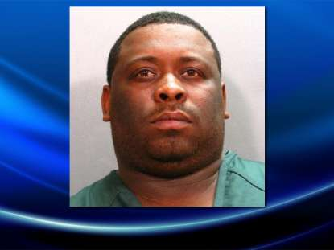
Jacksonville Sheriff's Office
Leonardo Marquette Little
A police officer who shot and killed a Jacksonville man following a November traffic stop was justified in firing his weapon after the two struggled, according to a finding by the State Attorney’s Office.
Officer Cecil Grant was justified in shooting Leonardo Marquette Little, 33, after the stop on 103rd Street near Interstate 295, according to a use-of-force review released this week.
Grant pulled over the car Little and a woman were in after noticing an expired tag. Little gave the officer multiple names and birthdays that proved to be false. Grant had Little get out of the car and told him he was under arrest.
The six-page report states that Little made a sudden move as he was being handcuffed. Grant was able to place one cuff on the suspect’s wrist, but when he went to cuff the other wrist, Little started throwing punches, police said.
Little punched Grant several times and broke away. Grant pulled his Taser and stunned Little, who fell then got off the ground, according to the report. Grant tried to deploy the Taser a second time, but it failed to work, the report said. The two men struggled and Little grabbed the Taser after Grant tried to use it two more times.
Little pointed the Taser at Grant, who then pulled his gun and shot twice, striking Little in his left arm and chest with one shot and both legs with the other, according to an autopsy. Little was declared dead at the scene.
Little told the passenger in the car that his license was no good and that he didn’t want to go back to jail, according to the report.
Dana Treen, (904) 359-4091

Updated: 8:12 p.m. Tuesday, Nov. 25, 2014 | Posted: 9:02 p.m. Monday, Nov. 24, 2014

33-year-old man shot, killed during traffic stop

Related
View Larger
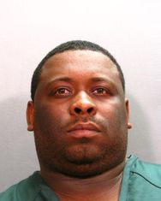
Jacksonville Sheriff's Office
The Jackosnville Sheriff's Office identified the man Tuesday during a news conference as Leonardo Little.
The Jacksonville Sheriff's Office is responding to a police-involved incident in the 7000 block of 103rd Street.

JACKSONVILLE, Fla. —
A 33-year-old man was killed during a traffic stop Monday night by an officer after police say that he fought back against three tasings and charged toward the officer.
The Jacksonville Sheriff's Office identified the man Tuesday during a news conference as Leonardo Little.
Patrol Officer Cecil Grant, who has been with JSO for 1 year, attempted a traffic stop after spotting expired tags on a Buick on Interstate 295. Grant was able to get the vehicle to pull over on 103rd Street, according to JSO Chief Tom Hackney.
Hackney said Little gave the officer several different names and after investigating the names, 30 minutes later, Grant found a name and a photograph to match the subject, who had a suspended driver's license.

Trending: Man, 19, hit by Jeep on U.S. 1 in St. Augustine

Grant asked Little to step out of the car, Hackney said. As Grant began to place Little under arrest and got one handcuff on, Little began to fight Grant, Hackney said.
Grant was pushed back, Little swung at the officer and began to run away. During the chase, Grant was able to strike Little with his Taser, causing Little to fall on the ground.
Hackney said Grant tried again to get both handcuffs on Little when the struggle restarted. A second and third strike from Grant's Taser had no effect and Little got hold of the Taser.

Related Link: Today's Top Stories.

"The subject was able to gain full control of the officer's Taser. Officer loses it from his hand, subject gets it in his. So the subject is now armed with the officers Taser as well as one hand-cuffed hand. Now that's not just a handcuff, those can be used as a weapon," Hackney said.
When the subject regained his footing, the officer then gave him a command to stop, Hackney said. Armed with the Taser and one handcuff, the subject charged at the officer, at which point the officer fired two shots at the subject. Little died at the scene.
Per administrative policy, Grant will be placed on administrative leave, Hackney said. Little's family is now being represented by a local attorney. The case is being investigated by JSO and the State Attorney's Office and will go before the Response to Resistance Board.
- See more at: http://www.actionnewsjax.com/news/news/local/jso-police-involved-incident-westside/njFXF/#sthash.B6vC3b0L.dpuf
http://www.actionnewsjax.com/news/news/local/jso-police-involved-incident-westside/njFXF/

