Former Independence police officer indicted

Timothy Runnels faces federal charges after using Taser on Bryce Masters
UPDATED 6:36 PM CDT Mar 27, 2015

NEXT STORY
Jury: Time Warner Cable mostly to blame for JJ's restaurant explosion

- Text Size:
- A
- A
- A
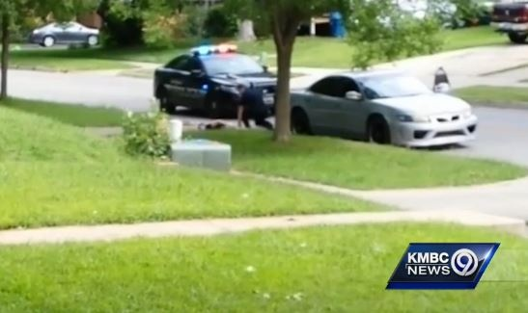
A federal grand jury has returned a four-count indictment against a former Independence, Missouri police officer Timothy Runnels.

KMBC
Advertising
INDEPENDENCE, Mo. —A federal grand jury has returned a four-count indictment against a former Independence, Missouri, police Officer Timothy Runnels.
- INCIDENT REPORT: OFFICER FOLLOWED TEEN BEFORE TRAFFIC STOP

More information is released about what led to a teenager being hit with a Taser by an Independence police officer last Sunday afternoon.
MORE
According to the indictment, Runnels violated the constitutional rights of a minor who was in his custody and obstructed the subsequent investigation.
An incident report released in September showed that Runnels stopped Bryce Masters, 17, and smelled marijuana from the passenger's side window.
Runnels asked Masters to step out of the car, but he refused.
Cellphone video shows Runnels using a Taser on Masters.
According to the federal indictment, Runnels continuously deployed a Taser against Masters while he was on the ground and not posing a threat to Runnels or others.
The indictment also states, "Runnels deliberately dropped the minor headfirst onto the ground."
Runnels is no longer with the Independence Police Department.
He faces 10 years in prison for each of two counts of violating Masters' civil rights.
CLICK HERE TO READ THE FULL INDICTMENT.
The Masters family released a statement after the indictment.
CLICK HERE TO READ THE FAMILY STATEMENT.
In it, family members say they've been a law enforcement family for eighteen years and understand the stresses of the job. However, they say Bryce Masters was denied the right to politely ask questions about detainment and was not given proper medical treatment.
http://www.kmbc.com/news/former-independence-police-officer-indicted/32056314

