Family gets $650K, policy changes in settlement of Taser death lawsuit

WCPO Staff
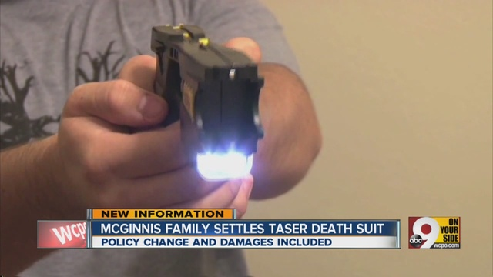
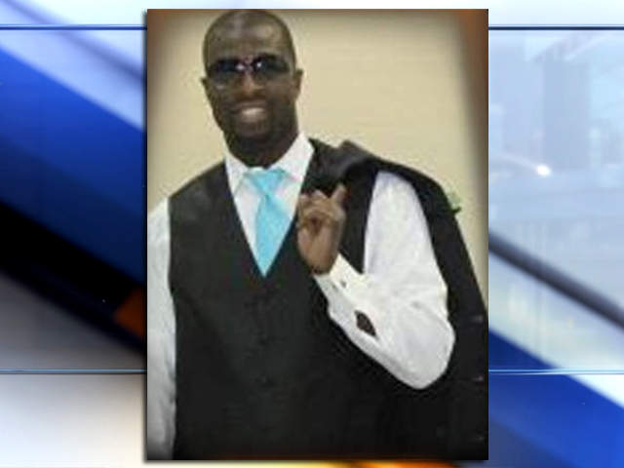
WCPO
SHOW CAPTION
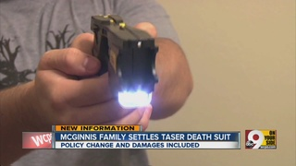
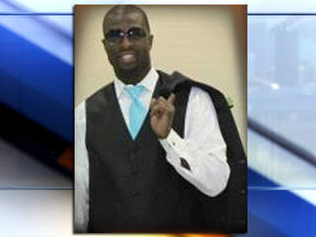
NORTH COLLEGE HILL, Ohio -- The family of a man who died after a North College Hill police officer used a Taser on him has resolved a wrongful death lawsuit against the city for $650,000 and changes to the police department's policy regarding use of the weapon.
Corey McGinnis, 35, was playing basketball at Crutchfield Park in Springfield Township in June 2012 when a fight broke out and shots were fired.
When police arrived on the scene, they used Taser weapons on three men, including McGinnis, to control the crowd.
Records show North College Hill police Sgt. Ryan Schrand struck McGinnis in the chest with a Taser.
The Forest Park man, who has nine children, collapsed immediately. He died at University of Cincinnati Medical Center five days later.
A testing report on the Taser used in the incident obtained by WCPO’s I-Team showed that the weapon was operating outside the manufacturer’s specifications, indicating the Taser may have sent more electricity into McGinnis’ body than it was designed to.
In addition to the financial settlement, the police department has agreed to several changes to its policy and training regarding the use of Taser weapons. The settlement, which still must be approved by a probate court, states that North College Hill Police Department promises to:
- Amend its Taser policy to reflect the manufacture’s preferred target zone
- Grade officer examinations taken during Taser training
- Conduct complete use of force investigations following Taser deployments
- Take reasonable efforts to participate in national registry regarding Taser impact if one is established
- Implement the reforms through a neutral expert with input from the family's lawyer, Al Gerhardstein
“North College Hill should be commended for including reforms in this settlement. The McGinnis family wanted the case to help improve Taser policies and training,” Gerhardstein wrote in a release. “The settlement sends a message to all local law enforcement agencies that they should honor the preferred target zone, make sure officers are competent with the weapon, and do thorough investigations.”
Gerhardstein called the policy changes significant and he hopes other departments will follow suit.
"It's a big deal... any one loss of life that wasn't intended by the officer, wasn't supported by the risk to the public or the officer and was just a mistake, can be prevented and will be prevented if they just follow these preferred target zones."
One of the attorneys representing the McGinnis family, Konrad Kircher, said the funds will be used to support the “Education and other needs of Corey’s children.
“His sister Yolanada McGinnis has been a great advocate for her nieces and nephews and has honored her brother the best way possible through this settlement,” he said.
WCPO has reached out to both parties and will update this story when more information is available.
Copyright 2013 Scripps Media, Inc. All rights reserved. This material may not be published, broadcast, rewritten, or redistributed
http://www.wcpo.com/news/local-news/hamilton-county/north-college-hill/family-of-man-settles-suit-against-north-college-hill-after-taser-death

