MINUTES
Rochester Historical Commission
400 Sixth Street, Rochester, MI
August 27, 2026
Bill Pietrzyk, Chair; Cy Saverino, Treasurer

Members: Bill Pietrzyk, Bob Michalka, Cy Saverino, Donald Washeleski, Donnie Sienkiewicz, Eric Bothwell, Gail Bothwell, Josephine Sokoloski, Julia Johnson, Kay Johnson, Lynn Anderson, Matthew Suhr, Pat Kane, Tim Petro, Mayor Debbie Jones

Attending: Bill Pietrzyk, Cy Saverino, Donald Sienkiewicz, Josephine Sokoloski, Lynn Anderson, Tim Petro, Lynn Anderson

Absent: Bob Michalka,, Donnie Sienkiewicz, Eric Bothwell, Gail Bothwell, Julia Johnson, Kay Johnson, Matthew Suhr, Pat Kane, Mayor Debbie Jones

MEETING CALLED TO ORDER AT 7:10 p.m. by Chair Bill Pietrzyk
MINUTES - Don S motion to approve July meetings, Cy seconded. Motion passes and minutes have been approved. Jo sent minutes to Megan asking where they need to be approved.
INTRODUCTION OF NEW MEMBERS - N/A
COMMUNICATIONS - No new mail.
TREASURER’S REPORT - One expenditure from city to the museum in July, no DUR books sold or plaques granted. Budget available to print more coloring books if needed.
PLAQUES - One application for a house on Wilcox street that is being finalized. One outstanding plaque that was delivered about a week ago. 4 plaques for calendar year to date.
ARCHIVES - Lynn received an update from Julie. Material related to 1969 community centennial is being used for several programs this year including a tea event and the biking tour with the library and museum. Next project to begin online for uploading newspapers, and providing examples of materials and ads. See “OTHER” section for the Museum's report.
FOUNDERS’ DAY 2027 - Tentative Date - March 21, 2027 (Sunday).
Unable to obtain underground railroad speaker. Unable to reach Masters student provided by the potential speaker. Underground railroad has been under a grant, meetings were held in rochester area, the presentation is primarily focused on Pontiac. Grant 2 has been awarded to research what else has happened in Rochester, Rochester Hills, Macomb, and Oakland Township. Carol Elizabeth Besak-Egbo. will give a presentation about the railroad and the people who lived along the river.
The new graham building, location. How will we give a presentation in this building?
Bagpipe lady and irish dancers will be contacted soon
HERITAGE DAYS - No updates.
DDA- 75% voted for the administration building to be public usage and findings should be presented by the end of August. The meeting was very well organized with approx. 75 attendees. The magical mural tour is up and going well, and is perfect in time for Arts and Apples coming up soon. Heritage Days are June 5th and 6th 2027. A future discussion to be had if all the cars will be able to fit and if they are available both days. The Granary is hosting a tour of community lifestyles, no current opening date set. Don to obtain count of second graders to distribute coloring books. There are about 120 books in inventory.
ROCHESTER CEMETERY COMMISSION - City council will revise a new amendment where you will not need a permit to walk your dog in a cemetery or in parks. More info to come on September 1st. Fundraiser for the cemetery some donations, matching funds until September 1st
Brochure is still being updated and Bill will provide updates.
NEW BUSINESS - Membership needs to be clarified. The city attorney has the bylaws, we are waiting on comments, and the City council needs a presentation. The attorney provided updates post-August meeting and will be reviewed at the September session.
OTHER - See Below the Museum’s report.
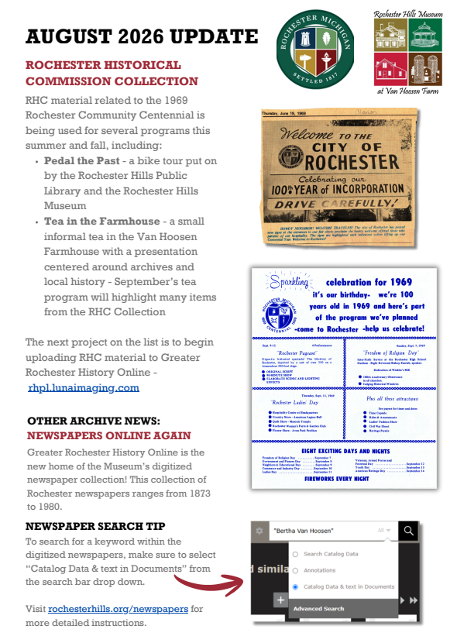
Meeting Adjourned at 8 p.m. Next meeting September 24th, 2027
Respectfully submitted by Jo Soko

